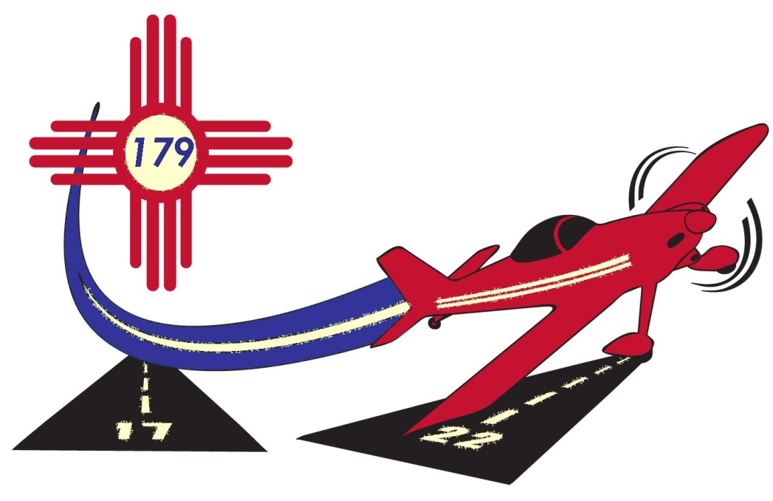
Double Eagle Aviation Academy
June 5 – 9, 2017
2017 APPLICATION
Applications must be received by April 29, 2017

Part I: Student Information:
Name (Please Print): _________________________________________Date of Birth: ____________________
Grade Level Fall 2017: _________Current GPA: ________ School in Fall 2017: ____________________
Male ____ Female____ Student’s shirt size (adult sizes): S____ M____ L____ XL___ 2XL____
Have you attended a similar program before? No ___ Yes____ If yes, explain__________________________
__________________________________________________________________________________________
How did you learn about the Double Eagle Aviation Academy? ___________________________________
__________________________________________________________________________________________
List community activities, hobbies and interests: ____________________________________________________
_____________________________________________________________________________________________
Part II: Aviation Interest – IMPORTANT! Class size is limited. Be thoughtful in your response.
- Please describe in your own words, “Why would you like to attend the Double Eagle Aviation Academy (DEAA)? What would you hope to gain from it?” Feel free to attach a separate page.

- List any experience or achievements with aviation to date. Attach a separate page as needed.

Part III: Parent or guardian must complete this section. Important – this part of the application MUST be completed and signed for consideration for admission to the Double Eagle Aviation Academy.
Parent / Guardian Information
Name: __________________________________________________________________________________
Address: ________________________________________City: ____________________________________
State: _________ Zip: _________________ Email (required): ______________________________________
Primary Phone Contact: (_____) ___________________ Alternate Phone: (_____) ___________________
Alternate Emergency Contact: Name: _______________________________________________________
Relationship to student: ______________________________ Phone: (______)_________________________

Student’s Medical History: Does the student have any health concerns/allergies/medications that we need to be aware of? Yes ___________ No__________ If yes, please explain: ___________________________ ________________________________________________________________________________________
Does the student have any dietary needs / food allergies that we need to be aware of?
Yes___________ No_________ If yes, please explain: __________________________________________
_______________________________________________________________________________________

WAIVER: The undersigned ("Participant") hereby acknowledges that he/she has voluntarily chosen to participate in DEAA. Participant acknowledges and understands that DEAA will involve activities that could potentially be dangerous or harmful. Participant has chosen to participate voluntarily, with the full knowledge of this potential danger and harm. By signing this document, Participant represents and warrants that he/she does not have any physical condition which could be aggravated or worsened by activity or stress. Further, I authorize EAA Chapter 179 to use photos and or other likenesses of my child for promotional purposes but not for sale to other parties. Images bearing these likenesses may be used for promotional materials and posted on the chapter website or Facebook page. In consideration of participation in this camp, Participant waives all claims, demands, actions, causes of action, and liabilities of any kind or nature, whether based in law or in equity, against the organizers, the volunteers, including EAA Chapter 179 and affiliates (“Affiliated Organizations”) arising out of or in any way related to DEAA or Participant's participation in the DEAA event. Participant releases EAA Chapter 179 and Affiliated Organizations from such Claims, regardless of when such Claims arise or when Participant discovers any injury or damage that does or may give rise to such Claims.

Given the above, I hereby give consent for my child to participate fully in the 2017 DEAA.

Parent/ Guardian Signature: _______________________________________________________________________
Print Name Signature Date

NOTE: Applications may be scanned and sent via email to chapter@eaa179.org OR by US mail to EAA179, Attn: DEAA; P.O. Box 3583; Albuquerque, NM 87190-3583. Applicants will be notified via email by May 8, 2017. Tuition ($99) is not due until accepted but must be received by May 15, 2017. Limited need based scholarships are available on request. For information, visit www.eaa179.org, call 505-974-5305 or email chapter@eaa179.org revision 3/31/2017

